SVAD 111: Course Project

AdventureWorks Product Review MVP
Milestone 3B
For Milestone 3B, you will install Microsoft SQL Server Tools, Apache, and PHP into your second Ubuntu virtual machine built in Milestone 1. First, make sure to power up your web server instance and connect to it via PuTTY.
Unless explicitly specified, any commands are single, continuous commands. This means you should enter everything in monospace type for a given command before pressing ENTER.

Step 1: Update the Operating System with Current Patches
Update the local repository:
sudo apt update
Run the updates:
sudo apt dist-upgrade –y
Reboot your instance:
sudo shutdown -r now

Step 2: Prepare the SQL Server Tools Components
- Import the GPG repository key for Microsoft:
curl https://packages.microsoft.com/keys/microsoft.asc | sudo tee /etc/apt/trusted.gpg.d/microsoft.asc
- Add the Microsoft repository for the SQL Server Tools:
curl https://packages.microsoft.com/config/ubuntu/22.04/prod.list | sudo tee /etc/apt/sources.list.d/mssql-release.list

- Update the Sources list
sudo apt-get update
- Install the necessary packages:
sudo apt-get install -y mssql-tools msodbcsql18 unixodbc-dev

Step 3: Install Apache httpd and PHP
Install the necessary packages:
sudo apt install -y apache2

sudo apt install -y php8.1 php8.1-dev php8.1-xml

Step 4: Install SQL Server Driver for PHP

- Install the SQL Server Driver:
sudo pecl -d php_suffix=8.1 install sqlsrv-5.10.0
- Install the SQL Server PDO Driver:
sudo pecl -d php_suffix=8.1 install pdo_sqlsrv-5.10.0
- Create configuration file for the sqlsrv module:
printf "; priority=20\nextension=sqlsrv.so\n" | sudo tee /etc/php/8.1/mods-available/sqlsrv.ini
- Create the configuration file for the sqlsrv_pdo module:
printf "; priority=30\nextension=pdo_sqlsrv.so\n" | sudo tee /etc/php/8.1/mods-available/pdo_sqlsrv.ini
The printf command outputs in a specific format. Here, it is interpreting the newline (\n) characters and taking action to split the single line into two separate lines. The tee command dumps the output to the standard output (your terminal screen) while also writing it to a file. It is popular to use tee in conjunction with sudo to take information created by a normal user and write it to a location where root or other permissions/ownership are required.
- Enable the modules within the PHP configuration:
sudo phpenmod -v 8.1 sqlsrv pdo_sqlsrv

Step 5: Configure and Start Apache httpd with PHP
- Disable the event worker:
sudo a2dismod mpm_event
- Enable the prefork worker:
sudo a2enmod mpm_prefork
- Enable PHP within Apache httpd:
sudo a2enmod php8.1

- Restart the httpd service to pick up the changes:
sudo systemctl restart apache2

Step 6: Validate Web Server Operations
- Create a test.php file in the web server’s root directory. Replace YOUR NAME HERE with your name:
echo '<?php echo "YOUR NAME HERE"; phpinfo() ?>' | sudo tee /var/www/html/test.php
- Navigate to your EC2 instance’s name, you will need to ensure to type http:// ahead of the system name so it doesn’t try to connect via the secure port. For example (this name will not work for you):
http://ec2-3-95-8-7.compute-1.amazonaws.com/test.php
If your web server is functioning correctly, you will see a screen like this:
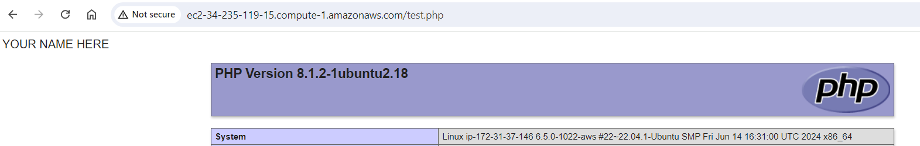
- Attach a screenshot of this such that it includes your name.
